**Explain about Decisions in Business Intelligence and different stages in the decision-making process**

* Decision-making is the process of selecting the best course of action from a set of alternative options to achieve a desired goal or objective.
* **Explorative Phase**: This is the initial step where different alternatives are identified. It's about searching for all possible options before narrowing down the focus.
* **Speculative Phase**: Here, you analyze the factors that might influence the decision. These could be internal or external forces, such as time, cost, resources, or risk.
* **Evaluative Phase**: This is the stage where each option is carefully compared against the set criteria (like pros, cons, potential outcomes, etc.) to evaluate which one offers the best benefits.
* **Selective Phase**: This is the final decision-making stage, where the most suitable option is chosen based on the analysis from the previous steps.

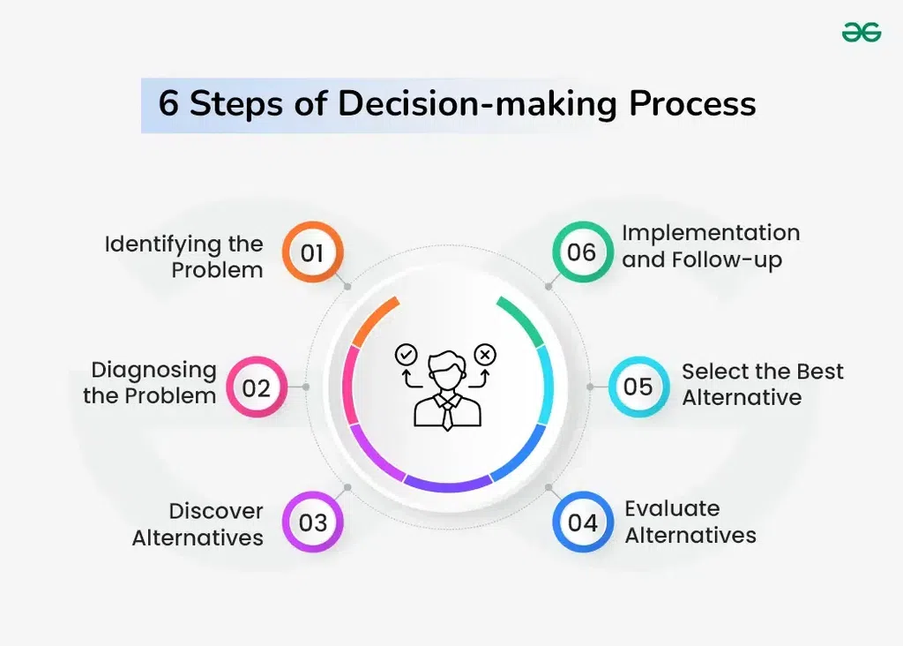

**1. Identifying the Problem**

* Recognize the gap between the current situation and the desired outcome.
* Problems may arise from internal issues or external changes (like market shifts).
* Managers must monitor situations closely to detect problems early.
* A clearly defined problem sets the stage for better decisions.
* Requires judgment, experience, and insight to identify real decision needs.

**2. Diagnosing the Problem**

* Managers must gather all relevant information before jumping to conclusions.
* They should find out what is actually causing the problem, not just look at the surface symptoms.
* It’s important to understand how urgent or large the problem is.
* Sometimes problems are related to one another, so they must be viewed in context.
* These are things that could restrict options, like lack of funds, time, or manpower.

**3. Discover Alternatives**

* Managers should try to come up with multiple possible solutions using creativity and imagination.
* It is better not to accept the first solution that comes to mind.
* Only serious and relevant alternatives should be considered.
* Factors such as budget, regulations, and resources can limit the number of choices available.
* Proper research helps discover better and more innovative solutions.

**4. Evaluate Alternatives**

* Managers should study the advantages and disadvantages of every alternative.
* Both numbers (quantitative data) and expert opinions (qualitative factors) are used in evaluation.
* Every option should be judged based on what it costs and the benefit it offers.
* Managers need to see which option carries more risk and whether it is manageable.
* Factors like time, money, people, and results are used to choose the most effective option.

**5. Select the Best Alternative**

* Choose the solution that **best solves the problem** with minimal risk.
* Use **past experience**, **research**, and **logic** to guide choice.
* The best alternative should be **realistic and effective** under current conditions.
* Avoid emotional bias; use data and reasoning for the analysis.
* Make sure the decision is aligned with organizational objectives.

**6. Implementation and Follow-up**

* The decision should be turned into a clear plan with steps, people in charge, and a timeline.
* Managers must decide who will do what and what resources (money, tools, people) are needed.
* All team members and departments involved must understand what needs to be done.
* Managers should regularly check whether the plan is working as expected through regular feedback and reports.
* Make adjustments if problems arise during implementation.
* Ensure follow-up to evaluate if the decision achieved the desired result.

**Advantages:**

1. **Clarity** – Helps you think through options and choose wisely.
2. **Efficiency** – Saves time by giving a structured way to decide.
3. **Confidence** – Reduces doubt and helps you stick to your choices.
4. **Problem-Solving** – Helps break down complex issues into simpler steps.
5. **Goal-Oriented** – Keeps decisions aligned with long-term goals.

**Disadvantages:**

1. **Time-Consuming** – Thinking through every step can take time.
2. **Overthinking** – Too much analysis can lead to delays or hesitation.
3. **Biases** – Personal opinions may affect the choice, sometimes unfairly.
4. **Incomplete Information** – Decisions can go wrong if all facts aren't available.
5. **Stressful** – Some choices can be overwhelming, especially big ones.

**(Extra)**

**A Decision Support System:** A Decision Support System (DSS) is a computer-based tool that assists individuals and organizations in making informed decisions by analyzing large volumes of data and presenting it in a way that is easy to understand and use.

**Key Components:**

1. **Database:** Stores relevant data, both internal (like sales records) and external (like market trends), to provide a comprehensive information base.
2. **Model:** Contains analytical tools and algorithms that process data to identify patterns, forecast outcomes, and evaluate different scenarios.
3. **User Interface:** The part of the system that allows users to interact with the DSS, input data, and view results in an understandable format.

**Types of DSS:**

* **Data-Driven DSS:** Focuses on the collection and analysis of large volumes of structured data.
* **Model-Driven DSS:** Emphasizes the use of mathematical models to analyze complex scenarios.
* **Knowledge-Driven DSS:** Utilizes expert knowledge and rules to provide recommendations.
* **Document-Driven DSS:** Manages and retrieves unstructured information in various document formats.
* **Communication-Driven DSS:** Facilitates collaboration and communication among team members to support decision-making.

**Advantages:**

* **Improved Decision Quality:** Provides accurate and timely information, leading to better decisions.
* **Efficiency and Speed:** Automates data analysis, saving time and resources.
* **Enhanced Collaboration:** Supports group decision-making through shared information and communication tools.

**Disadvantages:**

* **High Cost:** Developing and maintaining a DSS can be expensive.
* **Complexity:** May require specialized knowledge to operate effectively.
* **Data Quality Issues:** The effectiveness of a DSS depends on the quality of the data it processes.